

Luca Guadagnino’s

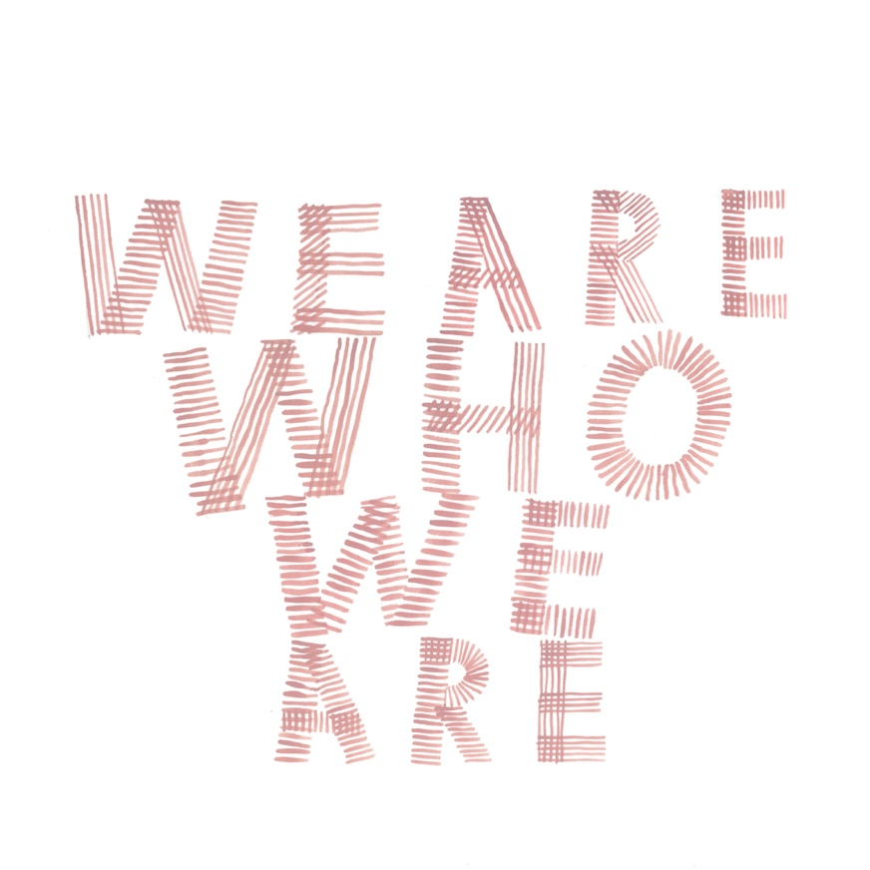
A SKY – HBO SERIES

Starring Chloë Sevigny, Jack Dylan Grazer, Alice Braga, Jordan Kristine Seamón, Spence Moore II, Scott Mescudi, Faith Alabi, Francesca Scorsese, Ben Taylor, Corey Knight, Tom Mercier and Sebastiano Pigazzi

a THE APARTMENT – WILDSIDE production, part of FREMANTLE,
with SMALL FORWARD

International Publicity:  International Rescue  Matthew Sanders  +44 7815 130 390  matthew@matthewsanders.org.uk  Charles McDonald  +44 7785 246 377  charles@charlesmcdonald.co.uk | Sky Italy PR:  Isabella Ferilli +39 346 720 7561 isabella.ferilli@skytv.it  The Apartment/Wildside PR:  Federica Ceraolo +39 3409172947 federica.ceraolo@gmail.com

CAST

Chloë Sevigny SARAH
Jack Dylan Grazer FRASER
Alice Braga MAGGIE
Jordan Kristine Seamón CAITLIN
Spence Moore II DANNY
Scott Mescudi RICHARD
Faith Alabi JENNY
Francesca Scorsese BRITNEY
Ben Taylor SAM
Corey Knight CRAIG
Tom Mercier JONATHAN
Sebastiano Pigazzi ENRICO

CREW

DIRECTOR/SHOWRUNNER LUCA GUADAGNINO

STORY PAOLO GIORDANO
AND SCREENPLAY FRANCESCA MANIERI
LUCA GUADAGNINO

CINEMATOGRAPHY FREDRICK WENZEL
YORIK LE SAUX
MASSIMILIANO KUVEILLER

EDITING MARCO COSTA

ADDITIONAL
ORIGINAL MUSICS DEVONTÉ HYNES

PRODUCTION DESIGN ELLIOTT HOSTETTER

COSTUMES GIULIA PIERSANTI

CASTING CARMEN CUBA

PRODUCED BY THE APARTMENT – WILDSIDE (part of FREMANTLE)
WITH SMALL FORWARD

A JOINT PRODUCTION HBO, SKY

Executive producers:
LORENZO MIELI
MARIO GIANANI
LUCA GUADAGNINO
ELENA RECCHIA
NICK HALL
SEAN CONWAY

FRANCESCO MELZI D’ERIL
WITH THE SUPPORT OF REGIONE EMILIA ROMAGNA

LAZIO REGION - REGIONAL FUND FOR CINEMA AND
AUDIOVISUAL

INTERNATIONAL DISTRIBUTION FREMANTLE

DURATION:

Episode 1: 58 minutes
Episode 2: 50 minutes
Episode 3: 57 minutes
Episode 4: 50 minutes
Episode 5: 59 minutes
Episode 6: 47 minutes
Episode 7: 71 minutes
Episode 8: 56 minutes

SYNOPSIS

A coming of age story about two American teenagers who, along with their military and civilian parents, are living on an American military base in Italy. The series centers on friendship, first-love and all the unknowns of being a teenager, which could happen anywhere, but in this case, happens to be in this little slice of America in Italy.

Jack Dylan Grazer stars as shy and introverted fourteen-year-old Fraser, who moves from New York to a military base in Veneto with his mothers, Sarah (Chloë Sevigny) and Maggie (Alice Braga), who are both in the U.S. Army. Tom Mercier (Jonathan) plays Sarah’s assistant.
Jordan Kristine Seamón stars as the seemingly bold and confident Caitlin, who has lived with her family on the base for several years and speaks Italian. Compared to her older brother Danny (Spence Moore II), Caitlin has the closer relationship with their father, Richard (Kid Cudi), and does not communicate well with her mother Jenny (Faith Alabi).
Caitlin is the lynchpin of her group of friends, which includes Britney (Francesca Scorsese), an outspoken, witty, sexually uninhibited girl; the cheerful and good-natured Craig (Corey Knight), a soldier in his twenties; Sam (Ben Taylor), Caitlin’s possessive boyfriend, and Craig’s younger brother; Enrico (Sebastiano Pigazzi), a playful eighteen-year-old from Veneto, who has a weak spot for Britney; and Valentina (Beatrice Barichella), an Italian girl.

EPISODES SYNOPSIS:

EP 1
Fraser is 14, and he has recently moved to an American military base in Veneto, Italy, from New York. While familiarising himself with his new surroundings, he meets some other kids: from the start, he is intrigued by one of them, the mysterious Caitlin.

EP 2
Caitlin has her period for the first time, prompting her to reflect on the concept of femininity. In the meantime, her relationship with her father becomes strained. She leaves the house dressed as a boy. Fraser follows her and sees her flirting with a girl.

EP 3
Caitlin and Fraser become friends. She is thinking about having a sex change, and he has a crush on a young soldier. They aren’t sure about their sexual identities yet, and they pretend they are seeing each other so they can explore it undisturbed.

EP 4
Craig, a soldier who is a friend of the kids, is about to be sent off on a mission the following day. Caitlin, Fraser and the others help him arrange a last-minute wedding, which is followed by a big party in an abandoned villa.

EP 5
Caitlin is about to go out with Giulia, a girl she met when she was dressed as a boy. So she asks Fraser to cut off her hair, and help her pass herself of as a boy. The date ends up having unexpected consequences.

EP 6
Caitlin’s father punishes her for cutting off her hair. He takes her hunting with him, and tries to work out what’s going on with her. But he fails to grasp the dilemma his daughter is facing about her identity. Meanwhile, Jonathan and Fraser go out together for the day.

EP 7
Craig dies in Afghanistan. At the service, Caitlin’s father blames Fraser’s mother for what has happened. Fraser takes it out on her too, when his friends end up excluding him from an evening they organise in memory of their friend.

EP 8
Caitlin is about to leave the base and move to Chicago when Fraser asks her to sneak off to Bologna with him to see a concert. Fraser meets a boy, and Caitlin, too, has an exciting night which turns everything on its head for her.

LUCA GUADAGNINO’S NOTES

It all started in January 2017 immediately after the success of Call Me By Your Name at the Sundance Film Festival. The Executive Producer Lorenzo Mieli asked me whether I would be interested in doing a series on gender fluidity set in a typical American suburb.
Broadly speaking, I’m not really attracted to what English speakers call “topics”. i.e. sensitive subjects turned into narratives. But I found the idea of staging a US community intriguing; it was something that would have spurred me to come off the beaten track and explore new paths.
For some reason it made me think about the childhood of Amy Adams: the actress had told me years ago that she was the daughter of a US army soldier and was born and had spent her early life at the Ederle military complex in Vicenza. That memory somehow became a source of inspiration that led me to think: what if instead of depicting the American suburbs, which have become a stereotype of independent cinema, we conjured up a very specific community, like a group of soldiers stationed abroad with their families? A microcosm of military men and women who recreate their own America beyond the borders of their home country, for example in Italy…
From this idea a great partnership began with Francesca Manieri and Paolo Giordano, who had already begun working on a scenario before my involvement.
My contribution to the development of the script was mainly to say: let’s not limit ourselves to the action and to the plot, let’s concentrate on the characters, let’s try to stick as tightly as possible to their behaviour just like Maurice Pialat did - a director who, in contrast to the more opaque or minor figures of the cinema world, refused to be chained to the paradigms of the “reductio ad unum” and instead celebrated freedom.
For We Are Who We are I was not only influenced by his To Our Loves, but also inspired by other wonderful works of his, like Under the Sun of Satan, a film based on the Bernanos’ novel and which in 1987 earned him a Golden Palm at Cannes, which was hissed by the audience, much to his chagrin.
I like to think that his disillusioned vision of the sacred or his ability to make it emerge in a world of corruption influenced parts of the narrative of this coming-of-age story, in particular the construction of some of the characters like Danny.
I would like to clear a misunderstanding: when I pay tribute to a filmmaker I love, it doesn’t mean that my only paradigm or perspective is remaking one of their films to appropriate it or imitate it. My desire to celebrate an auteur is born out of an emotional, intellectual and moral encounter with majestic figures such as Maurice Pialat, Chantal Akerman or Bernardo Bertolucci.
Having devoured their films and their interviews, my tribute is an incitement to reflection in an ideal debate with masters who I feel I can interpret thanks to my knowledge of their intellectual system.
The spirit of Maurice Pialat lingers over the entire series, which I like to call a “film” in eight acts. And in fact, when we were developing the script and constructing the characters, he’d become our starting and arrival point.
So, with extreme patience, after some thorough research on the world of military bases and infinite meticulous work on the details, our gallery of characters vividly took shape: the kids, their families, the military microcosm…
With a view to the ensemble movies of masters like Demme, Altman, Rossellini or Fellini, in which every single character - even the smallest roles - are so authentic that they would remain fixed in the collective imagination, we tried to give dignity to everyone without creating a hierarchy or order of importance for the characters.
I like to think of “We Are Who We Are” as a sort of human comedy describing how, in our day and age, a group of expats in a military complex live through their idiosyncrasies, desires and neuroses.
Some may think I painted a utopian microcosm but, in actual fact, I describe a world that reflects what we are today. Why limit ourselves to represent only the median of everything that goes on in the real? Since I was a child, I’ve always instinctively refused this reading, this interpretation of life.
If the series is political, it’s because it somehow opens our gaze on the other and gives a voice, with less sugar-coating than in the mainstream, to a multitude of characters who are quite invisible or underrepresented on the screen.
Even two characters like Sarah and Maggie (Chloë Sevigny and Alice Braga), a same sex married couple, experience some internal dynamics that could come across as unsettling for a certain progressive English-speaking audience.
I can imagine that certain aspects of their characters and of their narrative arc could prove hard to understand or accept for some, because it’s difficult to imagine that a character who belongs to the minority LGBTQI community can express at once beauty and deep cynicism.

We Are Who We Are allowed me to change course once again, and not having a cynical approach to my work, I like to constantly call myself into question.
I’m not interested in refining a single manner of filmmaking, instead I like to think of a film as a product of handicraft, a unique piece that cannot be replicated.
For this reason, together with those who work with me, I constantly struggle over the details, over every aspect of the stage design.
Sloppiness being my greatest fear, if one day I find I’m no longer interested in details, I’ll stop making films.
Over the years I’ve learned to always leave a door open to improvisation during shooting; reason why I insisted I wanted the scriptwriters on the set. Because when you’re there filming even the briefest scene, you can’t help asking yourself a thousand questions. You ask yourself questions as director, and so do the actors, the prop handler and the set design, make-up and costume departments, and it’s important to capture ideas and keep them going round. In this sense improvisation is absolutely welcome; we should always remember and accept that reality is always there and will take care of shaping a scene. At first you never know the direction you’re taking, then your design gradually becomes more defined, and the more you manage to open yourself up to reality and go ahead, the better you understand what you’re doing.
You’re like a blind man groping in the dark who gradually begins to see again, or like a chid… ultimately every director and every film follows the same path as that of a new-born baby: at birth a baby sees everything out of focus, it can only make out the shadows and contours of the more familiar figures, its father and mother (or its two mothers or two fathers, or whatever), but then, as its eyesight develops, it gains consciousness of its parents and starts decoding the world.
My creative process is the same: it’s not as if because I have a career spanning twenty years I can just film anything the next day and know exactly what I’m doing... every time you direct a film, it’s something new, a rebirth: at first everything is out of focus, then gradually the contours start to appear, the shadows and outlines, and then you start seeing a little colour, you start distinguishing the individual shapes, and in the end you obtain a full vision.
I like the fact the series is entitled We Are Who We Are: it’s us, us together, “here and now”… and it was to subscribe as much as possible to this spirit that I betrayed my love for celluloid and returned to digital filming. I liked the idea of capturing, like in a mirror, a present capable of offering a glimmer of improvisation, of goings-on off screen, of the childhood, of life.

Luca Guadagnino

